1. <https://www.youtube.com/watch?v=gCHUGgcGV48&list=PL3cFiqLUjlYPGlWWszesTtdI3v0tcLe5E&index=2>
2. Text

   Description automatically generated
3. Let’s start with understanding about Market?
4. If we want to purchase something like Veg, Furniture, we go to market. Similarly, we go to Stock Market to purchase shares of a company.  
   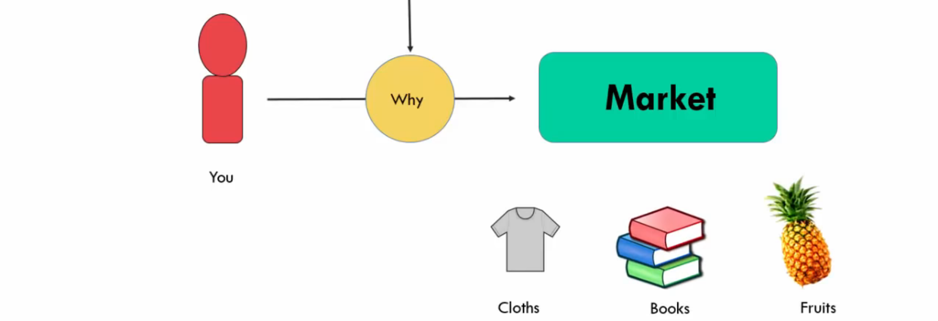  
   Diagram

   Description automatically generated  
   We don’t need to go to market to purchase shares but can do online.
5. **Shares VS. Stocks**:  
   Diagram

   Description automatically generated
6. Diagram

   Description automatically generated
7. A picture containing diagram

   Description automatically generated
8. 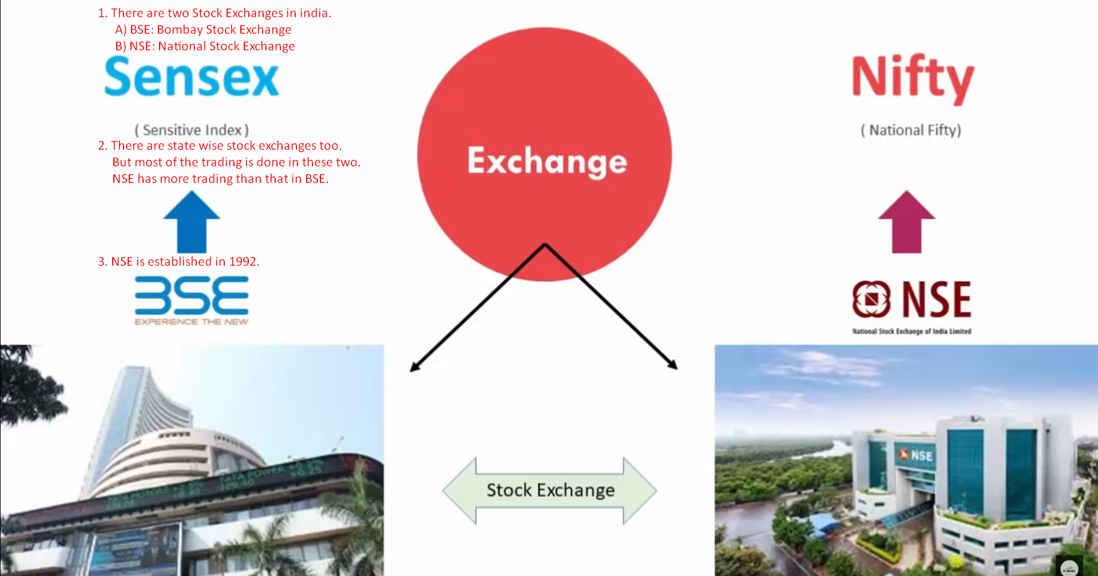
9. There are two ways to purchase shares of a company.
   1. Diagram

      Description automatically generated
10. Can we buy directly from Stock Exchange Website?  
    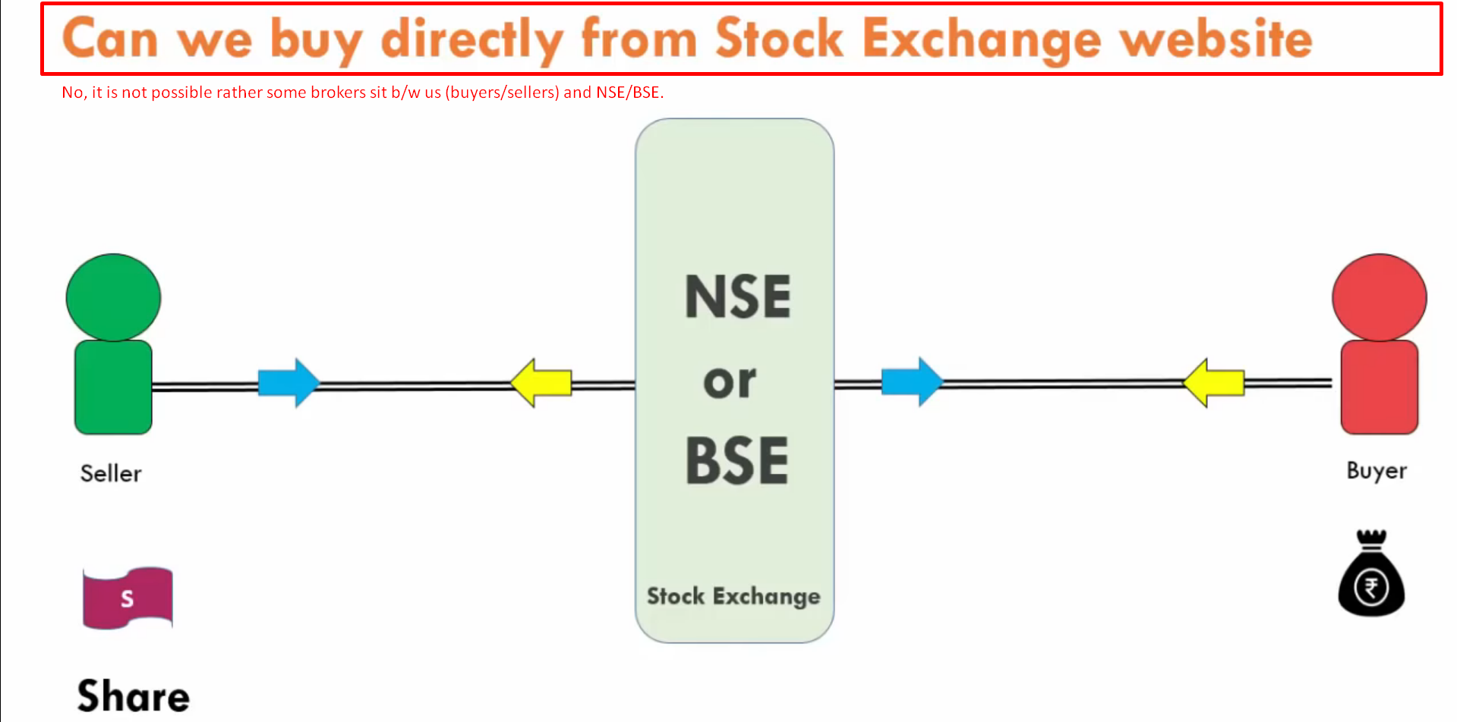  
    There are registered members to BSE/NSE and those are called 🡺 **Depository Participants** which are called **Brokers**.  
    So, to do any kind of trading (buying/selling shares) activities, you need to open account with a **Broker**.  
    It is very similar to Bank.   
    If you want to open with RBI, you can’t do it directly but go through public or private Banks and further transactions are settled through **RBI Route**.   
    Similarly, any trading will go to NSE/BSE through Broker (Depository Participant) and settlement will be done by NSE/BSE.
11. 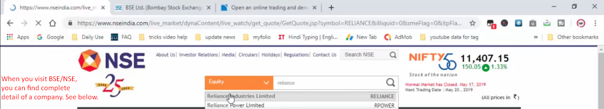
    1. Turnover.
    2. Market Capital.
    3. Share Price.
    4. float Size.
    5. Turn Over so far.
    6. Profit of a company.
    7. Who is promoter.
12. 